**Project Design Phase-II**

**Data Flow Diagram & User Stories**

|  |  |
| --- | --- |
| **Date** | **19 October 2022** |
| **Team ID** | **PNT2022TMID17578** |
| **Project Name** | **A Gesture - Based Tool for Sterile Browsing of**  **Radiology Ideations Images** |
| **Maximum Marks** | **4 Marks** |

**Data Flow Diagrams:**

A Data Flow Diagram (DFD) is a traditional visual representation of the information flows within a system. A neat and clear DFD can depict the right amount of the system requirement graphically. It shows how data enters and leaves the system, what changes the information, and where data is stored.

**Simplified DFD:** 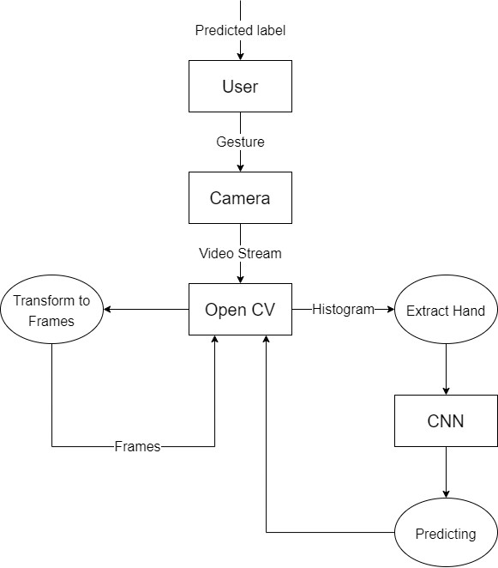

**Insdustry Standard DFD:** 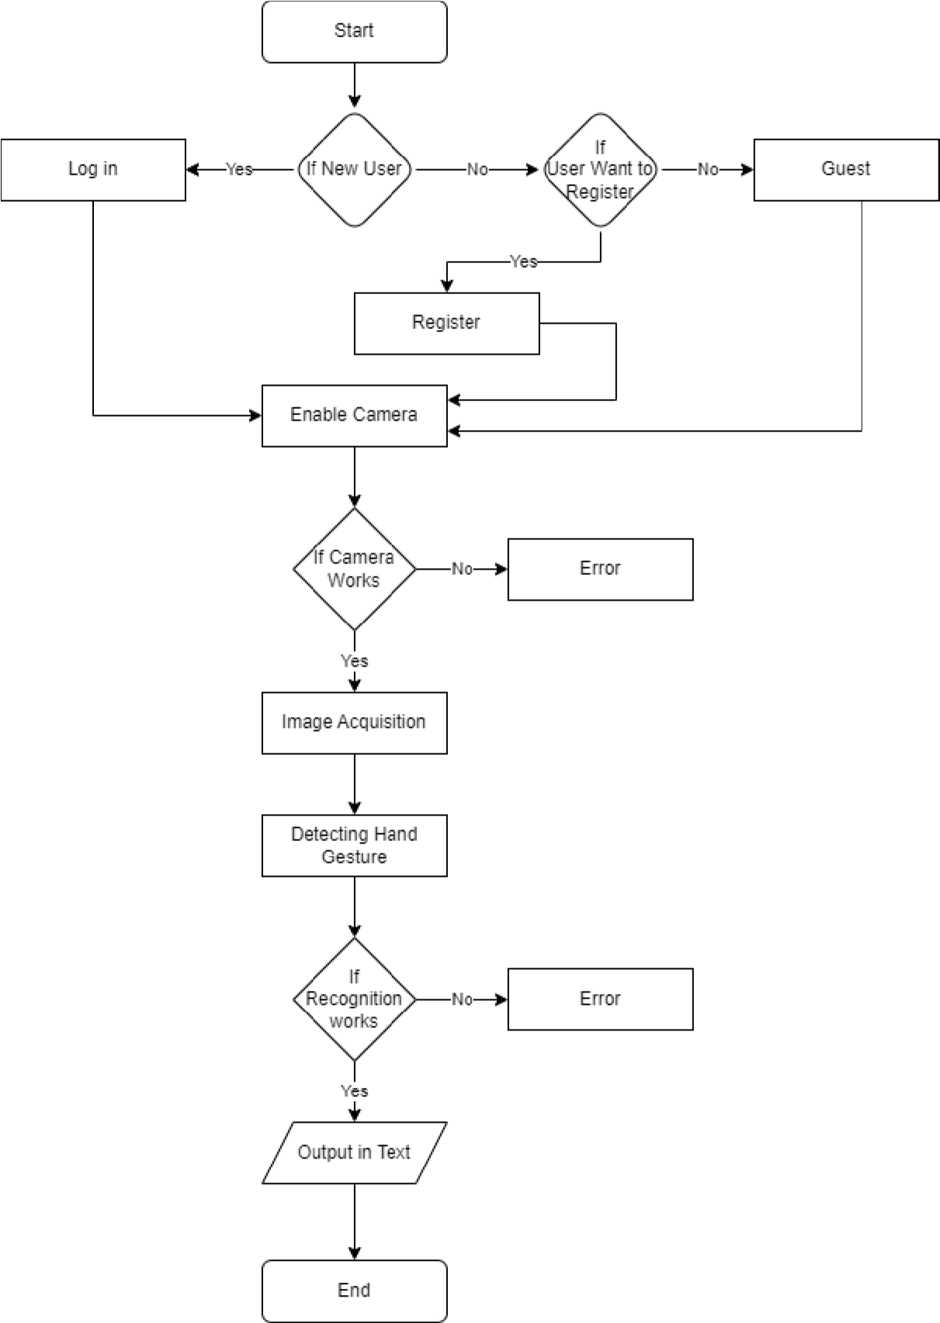

**User Stories:**

Use the below template to list all the user stories for the product.

|  |  |  |  |  |  |  |
| --- | --- | --- | --- | --- | --- | --- |
| **User Type** | **Functional**  **Requirement**  **(Epic)** | **User Story**  **Number** | **User Story / Task** | **Acceptance criteria** | **Priority** | **Release** |
| Customer  (Mobile user) | Registration | USN-1 | As a user, I can register for The Web Application by entering my email, password, and confirming my password. | I can access my account  / dashboard | High | Sprint-1 |
|  |  | USN-2 | As a user, I will receive confirmation email once I have registered for The Web Application | I can receive confirmation email & click confirm | High | Sprint-1 |
| Common | Login | USN-3 | As a user, I can log into The Web | If the registered | High | Sprint-1 |
| People and |  |  | Application by entering email & password | information matches the |  |  |
| Specially |  |  |  | given information accept |  |  |
| Abled People |  |  |  | login. |  |  |
|  | Dashboard |  | * The Dash board is simple, User- Friendly Interface and Common to Every User * After the amazing landing page, the user can log in with email and password or the user can use the access the feature as a guest | I can access my account / dashboard  I can access the features as a guest | High | Sprint 2 |

|  |  |  |  |  |  |  |
| --- | --- | --- | --- | --- | --- | --- |
| **User Type** | **Functional**  **Requirement**  **(Epic)** | **User Story**  **Number** | **User Story / Task** | **Acceptance criteria** | **Priority** | **Release** |
| Customer  (Web user) |  |  | Give access to camera to recognize the Hand  Gestures to communicate with the computer | I can access the camera and use it to  communicate message | High | Sprint 2 |
| Common  People | Feedback |  | Give access to comment about the software and share this Web application site to friends or end the session and restart over | I can give suggestion and recommend the site to my friends  Or I can end the current session and go out or restart the process | High | Sprint 3 |